# User Document

contents

User Document 1

Introduction and Overview 2

Deployment 2

Try Our System 3

Browser Approach 3

System Installation Approach 3

System Access 3

Login Interface 3

Registration Interface 4

Data Entry Guidelines 5

Navigation and Interface Functionality Explanation 6

Patient Perspective 6

Doctor's Perspective 14

Nurse Interface 20

Helping staff perspective 22

Admin perspective 23

Update and Version Control 27

Appendix 27

How to Contact us 27

## Introduction and Overview

Welcome to our hospital management system! This system aims to provide an efficient, secure, and comprehensive solution to support the daily operations and healthcare services of the hospital. Whether you are an administrator, doctor, nurse, assistant, or patient, our system will provide you with a user-friendly platform to manage and access important information related to your work and health.

Our system covers multiple key functional modules, including but not limited to appointment scheduling, diagnosis, examinations, rehabilitation, surgeries, hospitalization, and billing. Each functional module is specifically designed to meet the needs and responsibilities of different stakeholders. Whether you are an administrator managing specific information in the healthcare system, a doctor managing patient diagnosis information, or a patient making appointments and accessing medical services, our system will provide you with a simple and intuitive interface and functionality.

Our system also offers security and permission management features to ensure the confidentiality of sensitive information and data integrity. Different stakeholders will be granted appropriate access permissions based on their roles and responsibilities.

We aim to provide a efficient, accurate, and collaborative tool for healthcare teams and patients through this hospital management system, in order to optimize the delivery and management of healthcare services. Please read this user document for detailed explanations and operational guidelines of the system. If you encounter any issues during the usage, please feel free to contact our support team.

## Deployment

The system is supposed to run on the central server of the hospital. Use following instruction to deploy front-end and back-end on the server.

For front-end, a nodejs environment is needed.

cd front-end/

npm install

npx vite --host 0.0.0.0

For back-end, a python and MySQL database with 3306 port opened environment is needed. MySQL database should be configured in advance with username, password and running port number. And a database should be created to store the data. Before running following commands, the content of heading lines of api.py should be modified in order to connect to the database.



cd back-end/

pip install -r requirements.txt

python api.py

after running these commands, the system is deployed on 0.0.0.0: 5173. Other computers can visit this address in browsers to enter the system.

## Try Our System

### Browser Approach

We provide a deployed system running on the Internet which can be used from everywhere.

Visit 178.128.106.95:5173 to try our system!

The administrator account: username: a000000001, password: 123

### System Installation Approach

First unzip the package, and you will get the file as follows

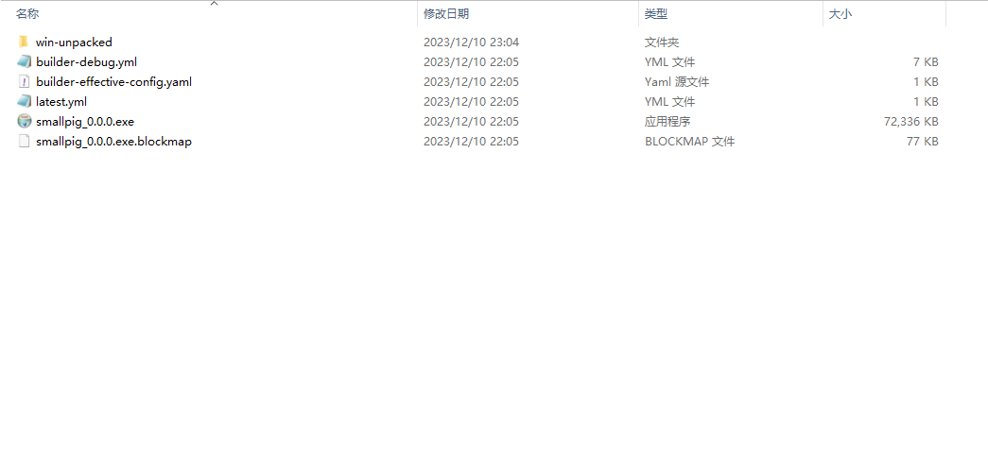

Then, click on smallpig_0.0.0.exe., You'll see the setup wizard.

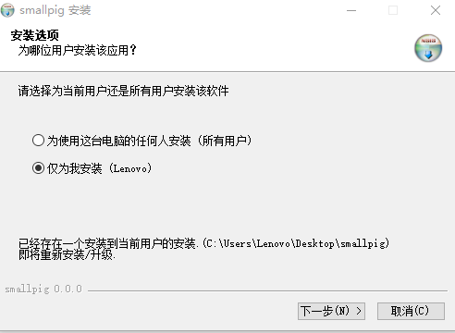

Follow the installation wizard to complete the installation.And then you will be able to access our system.

## System Access

### Login Interface

This is the login interface of our system. If you already have a system account, you can enter your correct ID and password here to access the hospital management system.

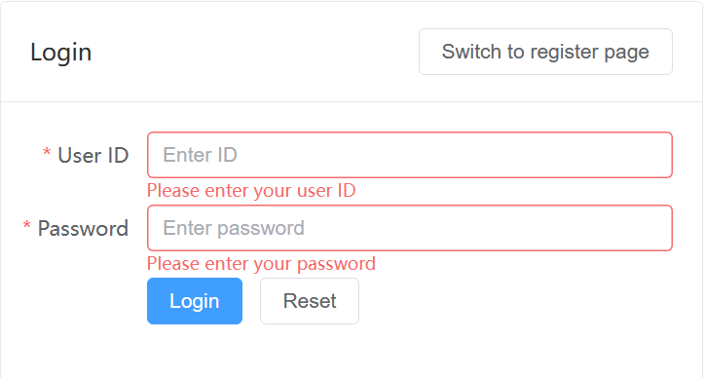

### Registration Interface

If you do not have a system account yet, you can switch to the registration interface by clicking on the option located in the top right corner of the login page. You can choose your role based on your situation and fill in your relevant information.

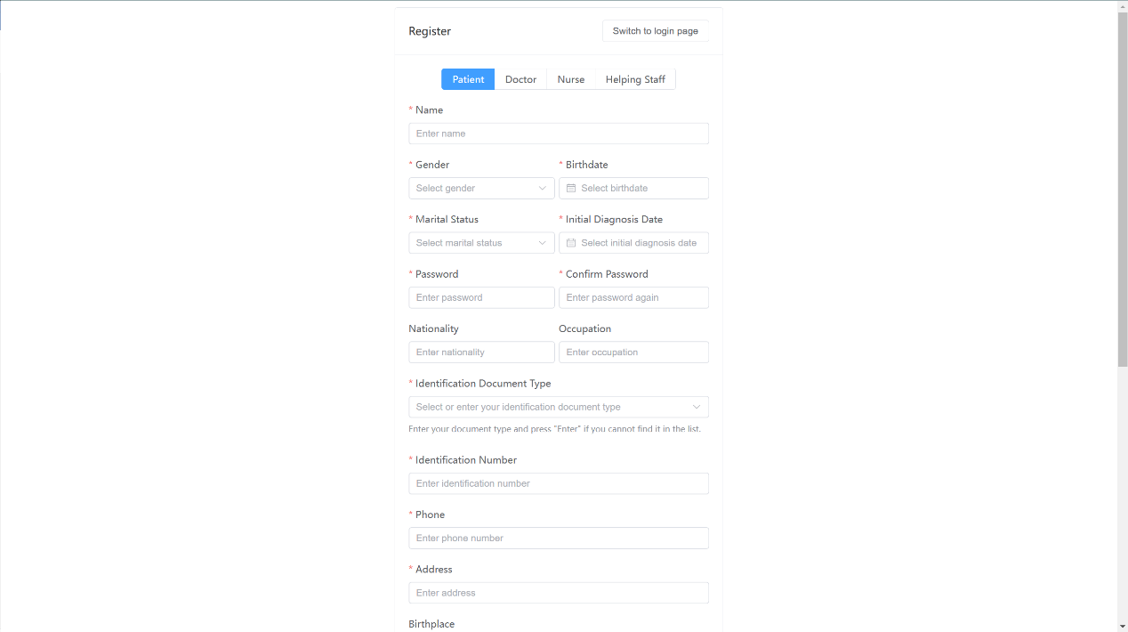

Please note that if required information is left blank or if the information provided does not meet the required specifications, the system will highlight the incorrectly filled fields and prompt you to re-enter the information.

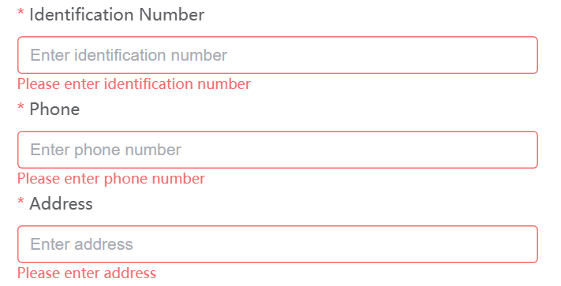

Furthermore, if you are an employee of the hospital, it is important to contact the system administrator promptly after completing the registration process to confirm your account registration. Until your account is confirmed by the administrator, you will not be able to use the registered account.

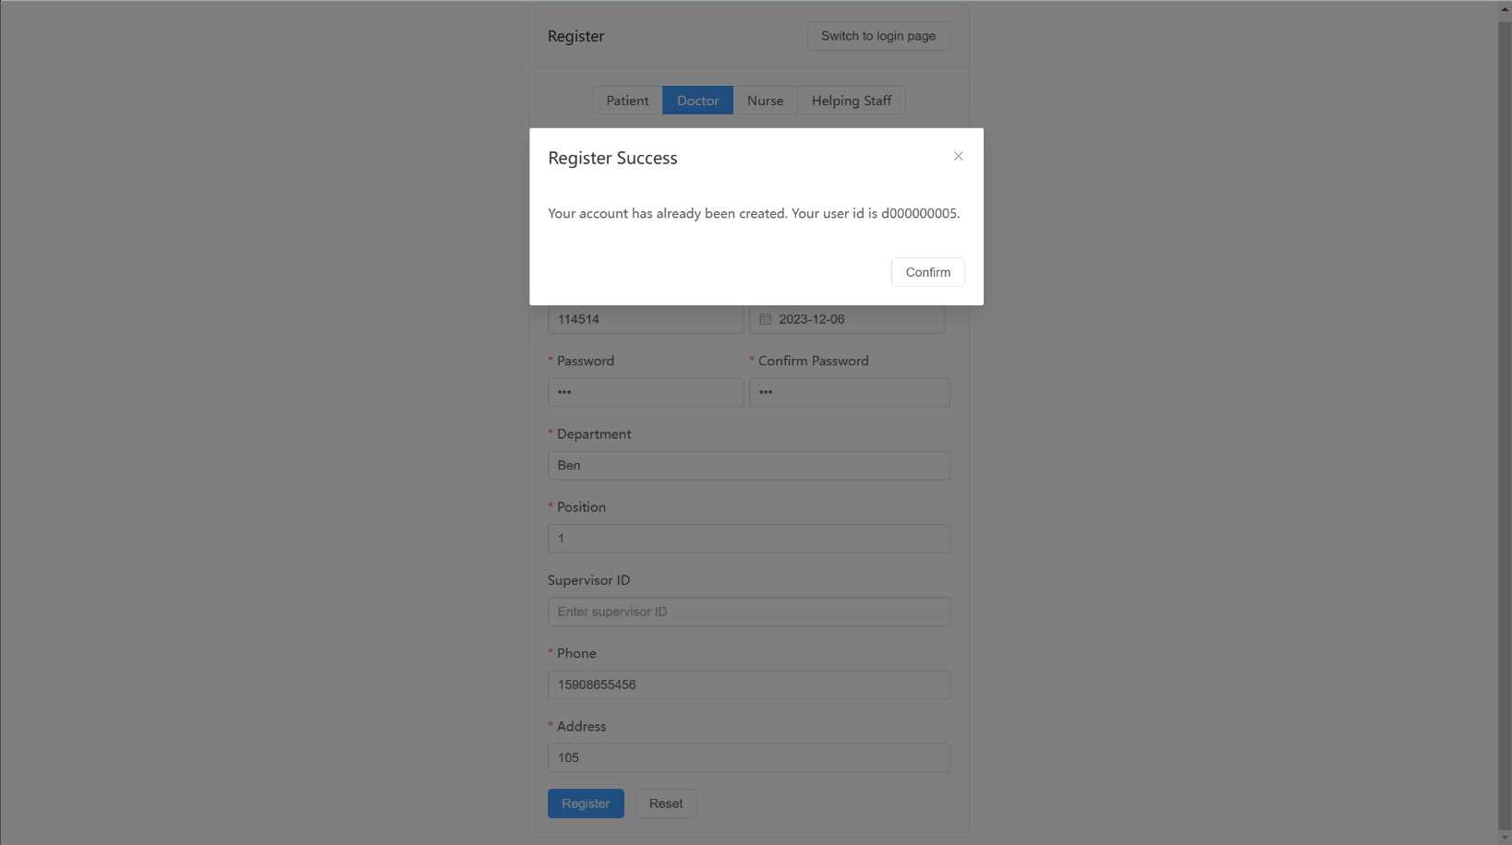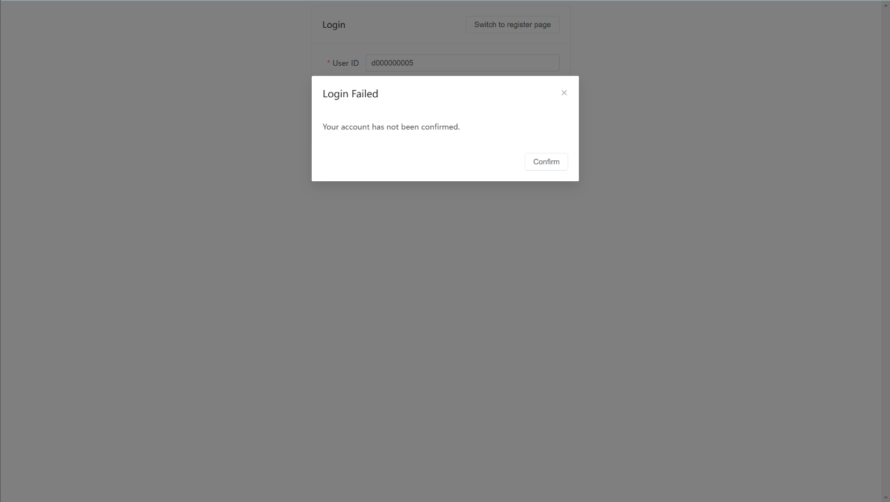

### Data Entry Guidelines

#### For the patient registration interface:

1. The fields marked with an asterisk (*) are mandatory. Non-mandatory fields can be selectively filled based on the actual situation. Unless otherwise specified, please do not exceed 255 characters for any field.
2. Select your gender from the dropdown menu.
3. Choose your date of birth using the calendar.
4. Select your marital status from the dropdown menu.
5. Choose your initial diagnosis date using the calendar.
6. Make sure that the password entered twice is consistent.
7. Fill in your nationality based on the actual situation.
8. Select your identification document information from the dropdown menu.
9. Fill in your identification number based on the actual situation.
10. Ensure that your phone number consists of 11 digits and contains only numbers.
11. Fill in your place of birth based on the actual situation.
12. Select your blood type from the dropdown menu.
13. Select your allergens from the dropdown menu.
14. Fill in your emergency contact person based on the actual situation.
15. Fill in the relationship of your emergency contact person based on the actual situation.
16. Ensure that the contact information of your emergency contact person consists of 11 digits and contains only numbers.
17. Fill in the address of your emergency contact person based on the actual situation.

#### For the doctor, nurse, helping staff registration interface:

For the doctor, nurse, and helping staff interfaces, they are similar.

## Navigation and Interface Functionality Explanation

### Patient Perspective

Once you have successfully logged in, you will see the interface as shown in the following image.

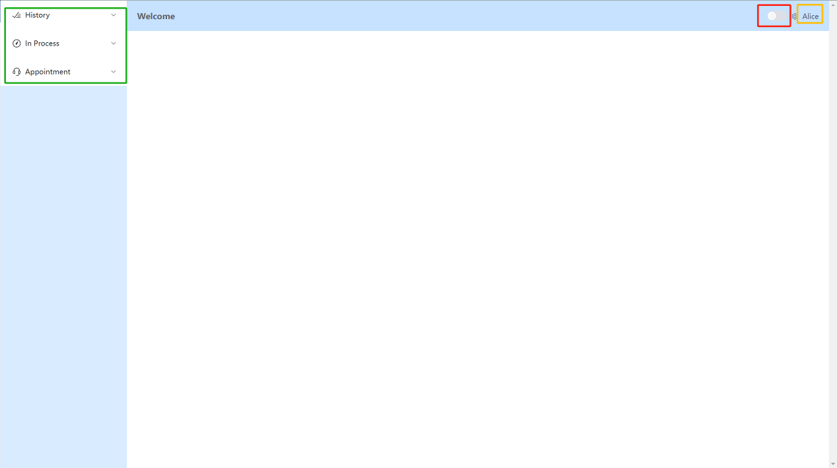

The buttons highlighted in red boxes allow you to freely switch between the day and night modes. The sections highlighted in yellow boxes contain your user operations, while the sections highlighted in green boxes encompass the main functionalities of the patient system. Below, we will explain each of their specific functions.

#### Day/Night Mode Switch

Clicking the button will toggle between the day and night modes.

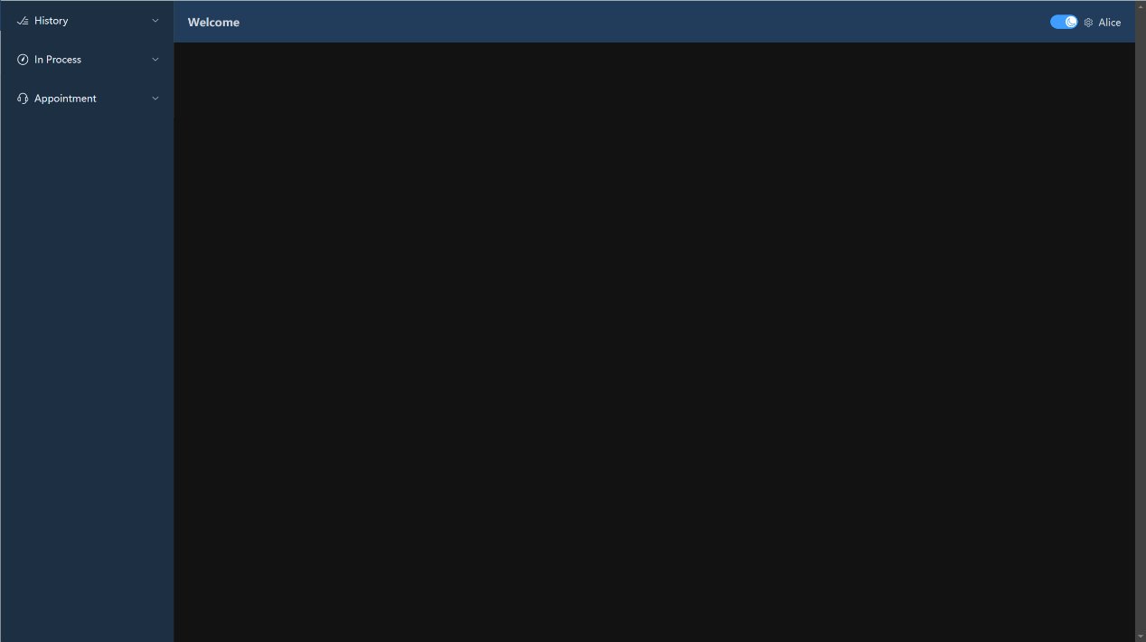

#### User Operations

Clicking on the gear symbol next to your username allows you to perform the following operations:

1. **Logout:**

This option allows you to log out of your account and end your current session.

1. **Edit Personal Information**

In this interface, you can modify all your personal information except for the user ID. The data entry guidelines mentioned earlier should be followed when updating your information.

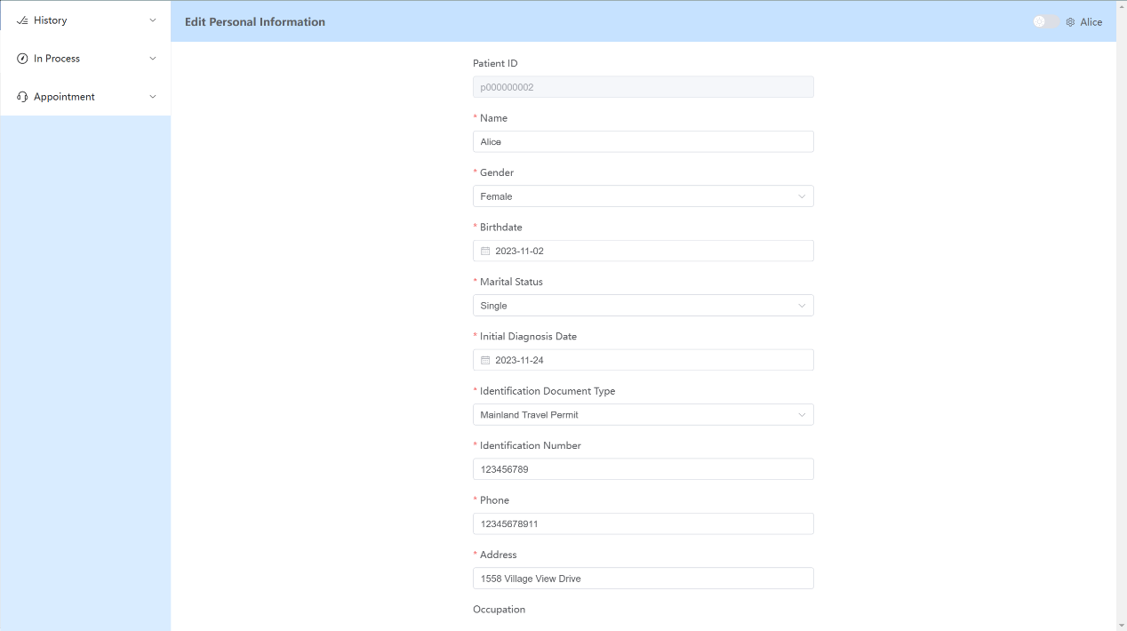

1. **Edit Password**

In this interface, you can change your account password. Please note that you will need to enter your old password and ensure that the new password and confirmation password match.

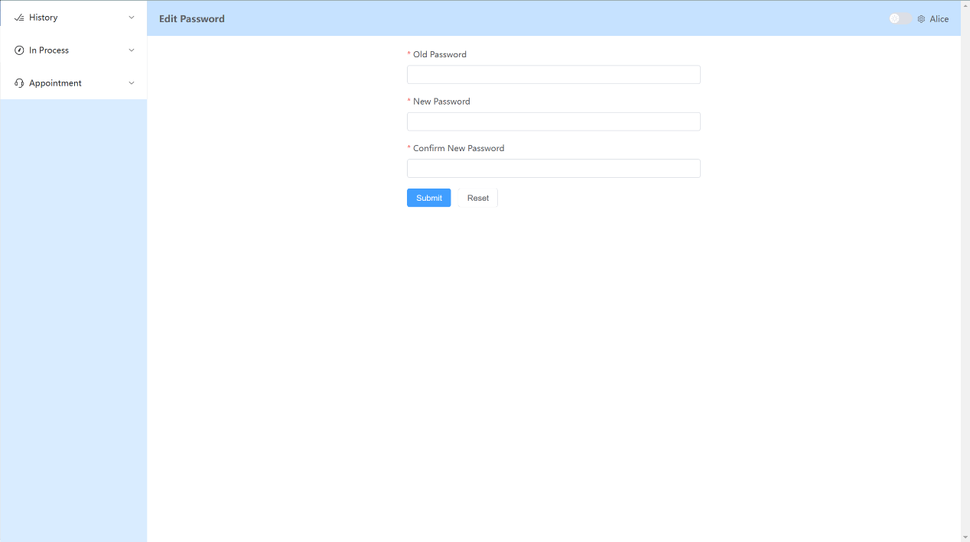

1. **View Personal Information**

In this interface, you can view your relevant information.

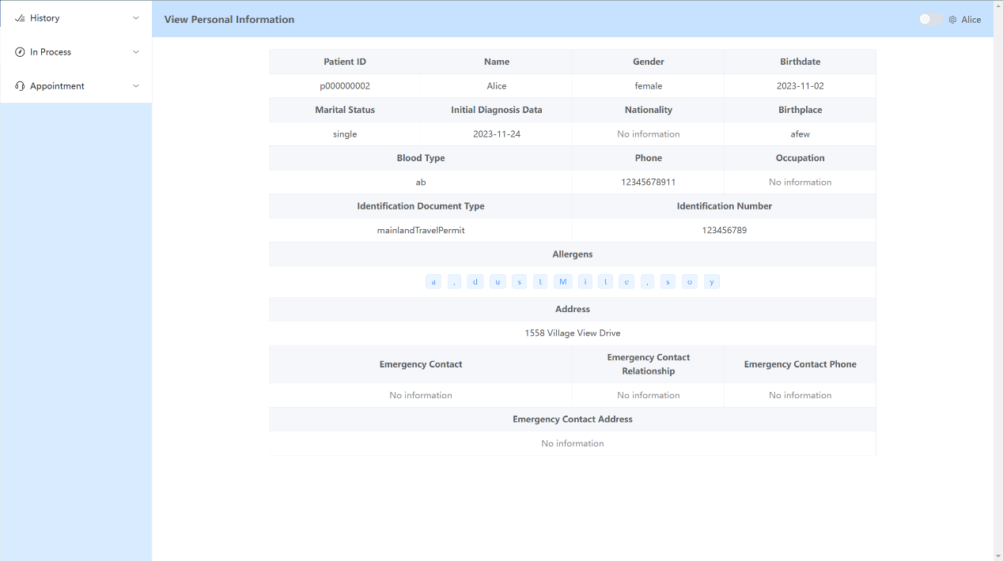

#### Main Function Operations

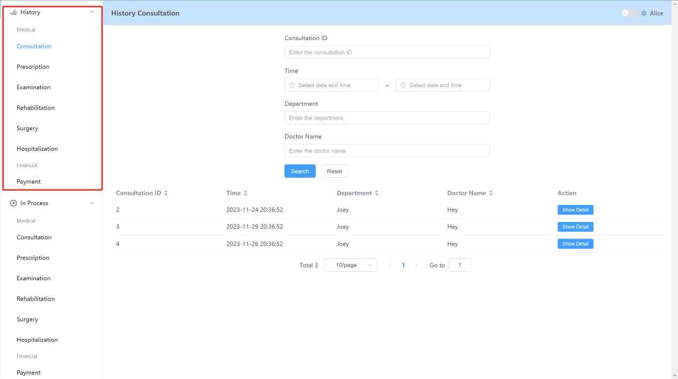

For the "History" section highlighted in red, you can see options such as Consultation, Prescription, Examination, Rehabilitation, Surgery, Hospitalization, and Payment Records. Let's introduce each of them individually:

1. **Consultation**

The Consultation interface allows you to view your consultation information. You can filter the consultation information based on specific criteria. If you do not set any filters, it will display all your consultation records.

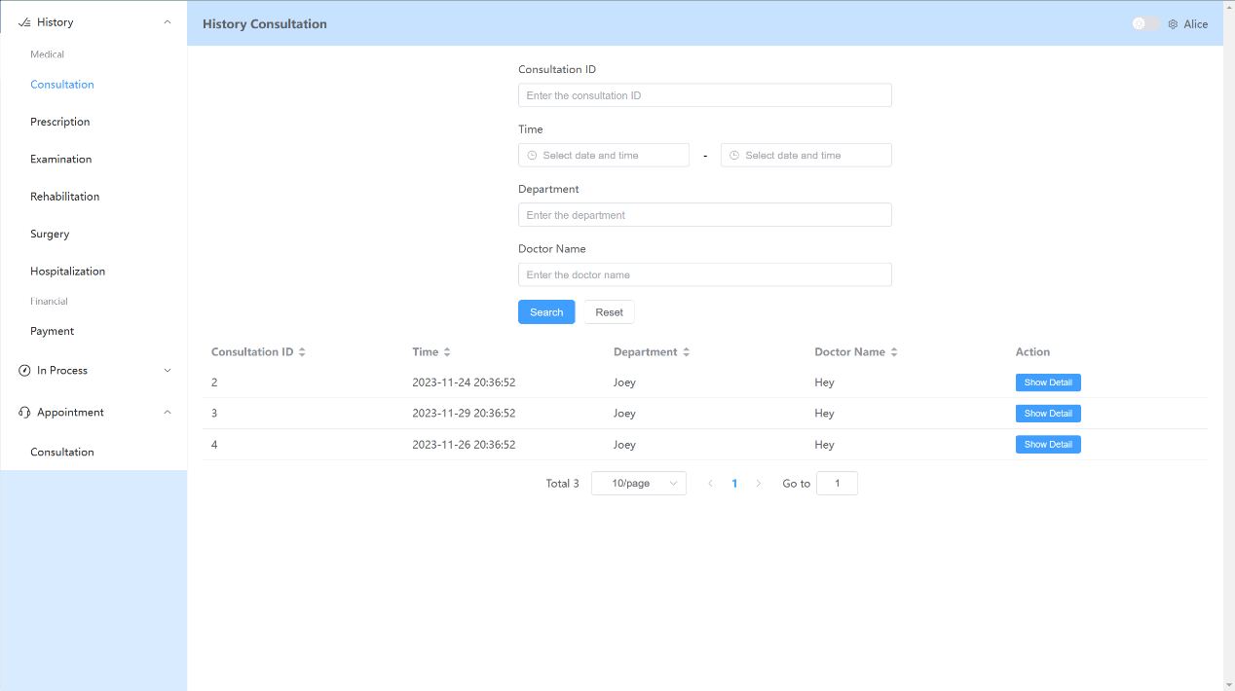

If you set search criteria, you can follow the prompts on the interface to specify the search conditions. Taking the doctor's name as an example, you can enter the relevant doctor's name, and the system will provide possible matching options based on your input and the actual records.

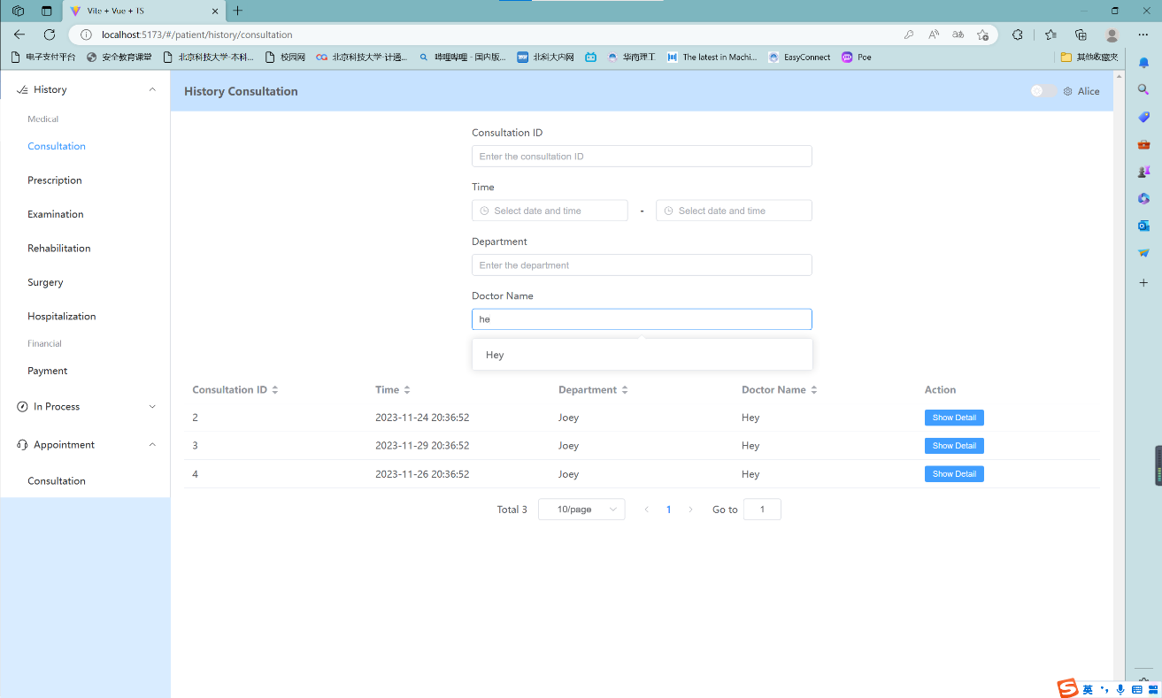

For each Consultation entry, on the far right side, clicking the blue "Show Detail" button will display the specific information for that particular Consultation. In this interface, you will be able to see all the relevant information, and some details can be further expanded by clicking the "Show Detail" button to display more detailed information.

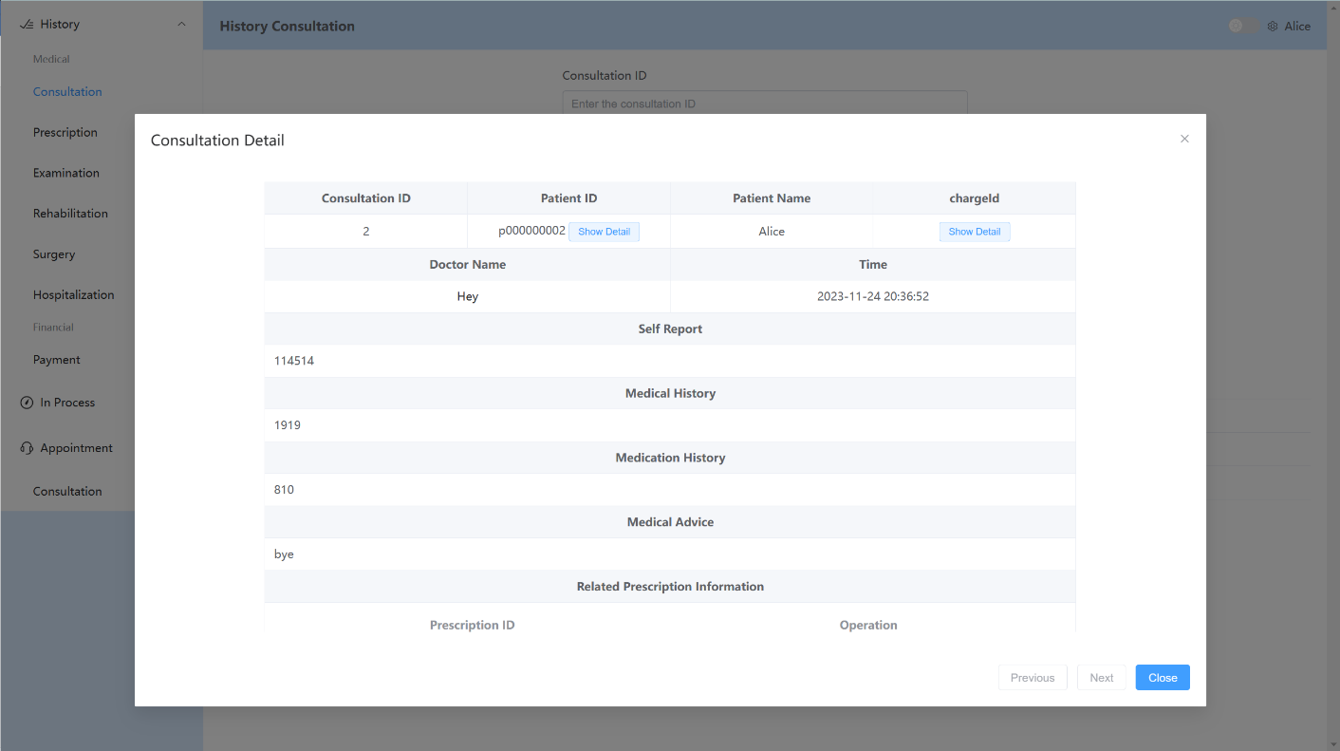

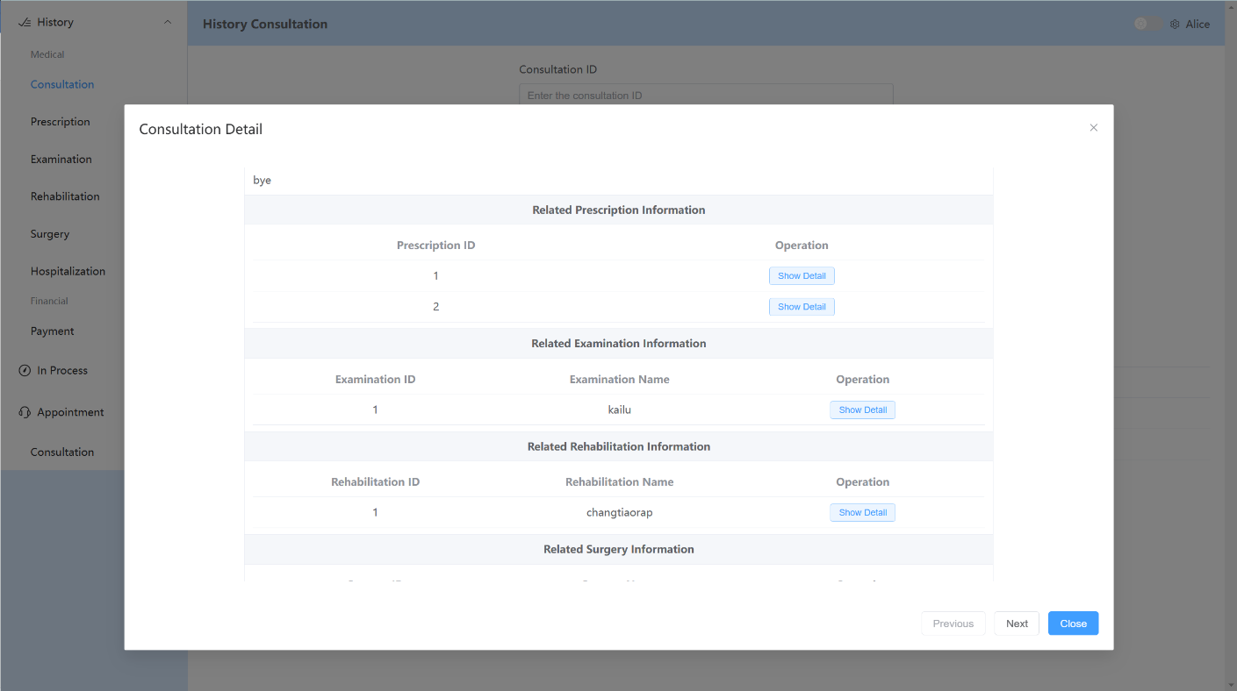

1. **Prescription**

The Prescription interface allows you to view your prescription information. Similar to the Consultation interface, you can use filters to search for specific prescription records. By clicking the blue "Show Detail" button, you can access the detailed content of the relevant prescription.

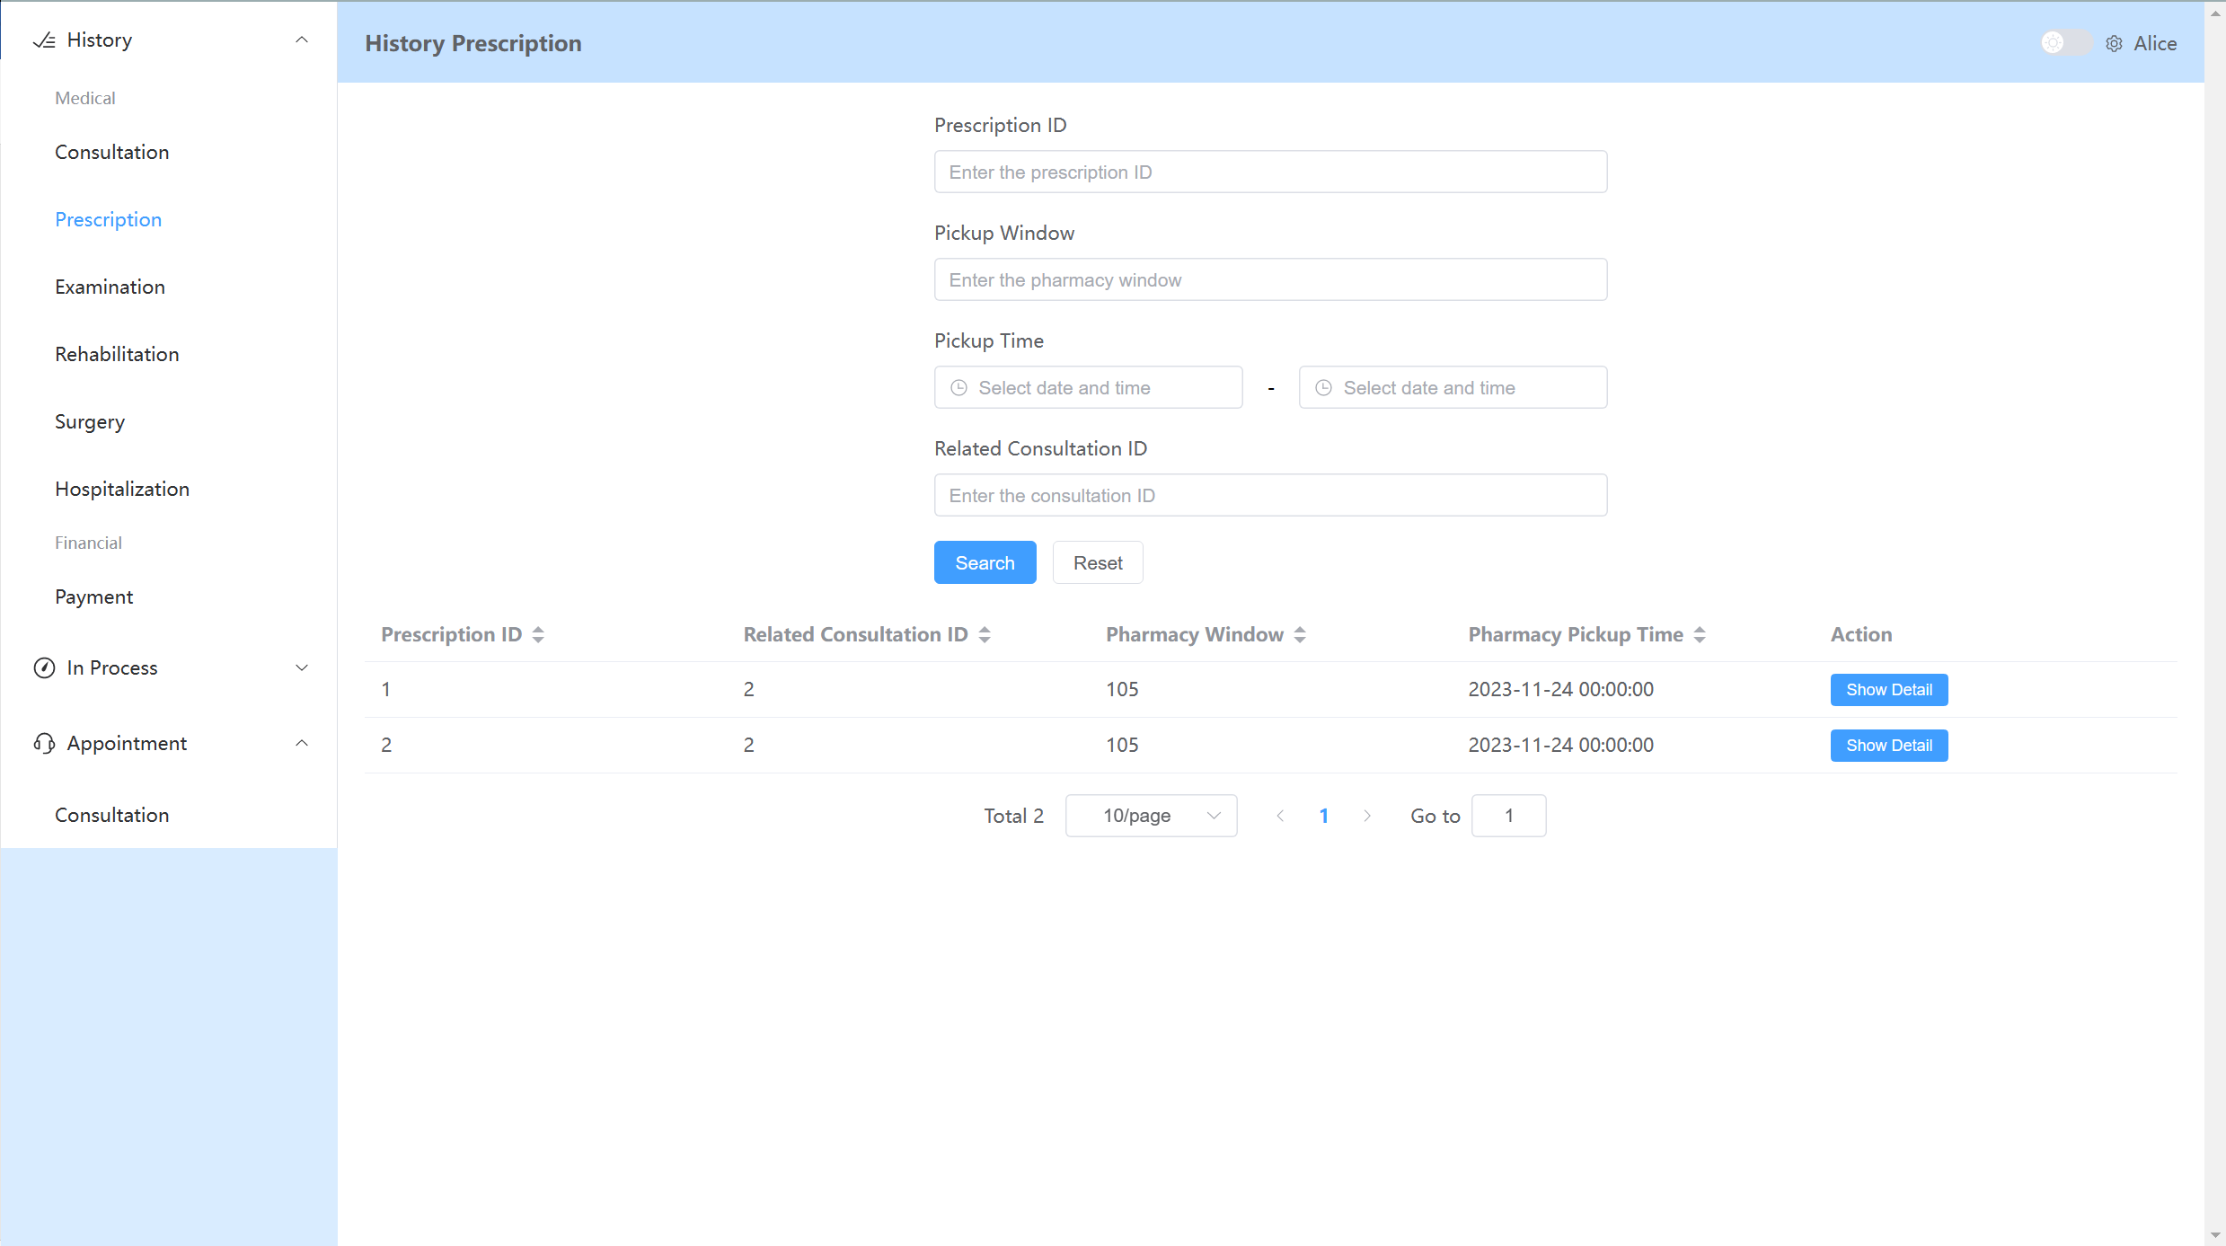

Once you click the "Show Detail" button, you will be able to see all the relevant information for the specific Prescription. This includes the time and location for medication pickup, as well as details such as the prescribed medication's name and quantity. Additionally, you can further explore the information by using the "Show Detail" button available on the interface.

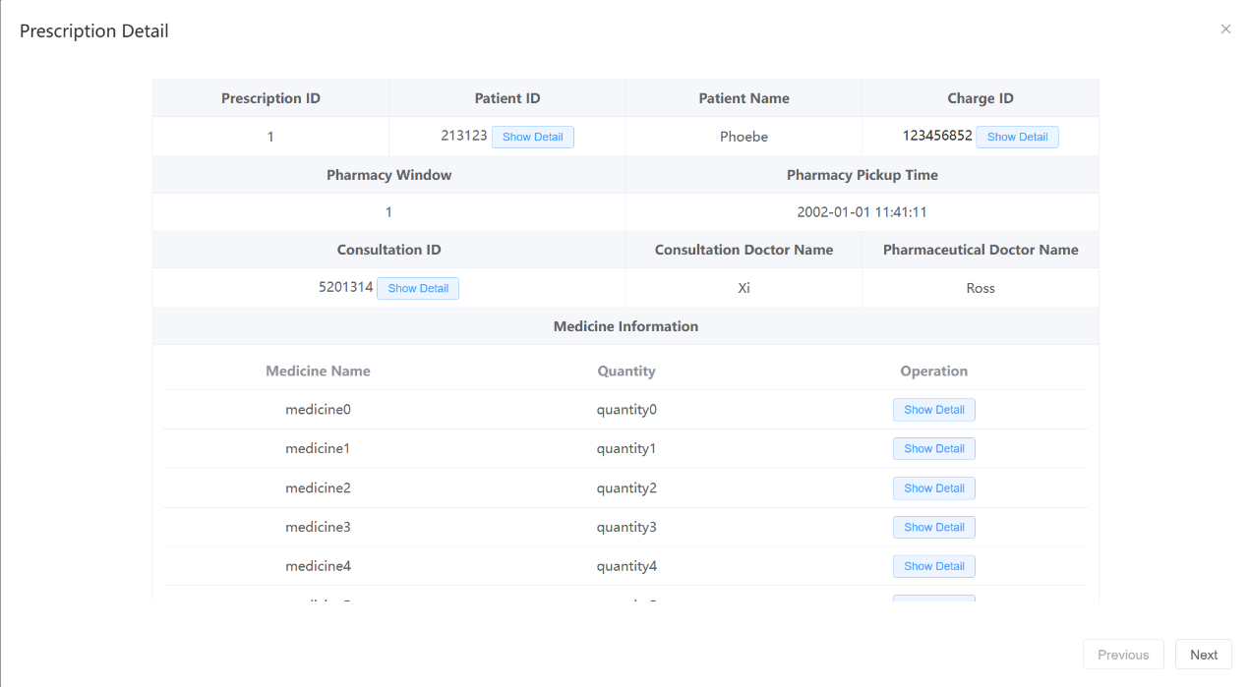

1. **Examination, Rehabilitation, Surgery, Hospitalization**

The functionality of these four interfaces is similar to what was previously described for Consultation and Prescription, so I will not repeat it again.

**4）Payment**

The Payment interface allows you to view your payment information. This interface supports searching for payment records using relevant information. By clicking the blue "Show Detail" button, you can access the specific details of the related payment.

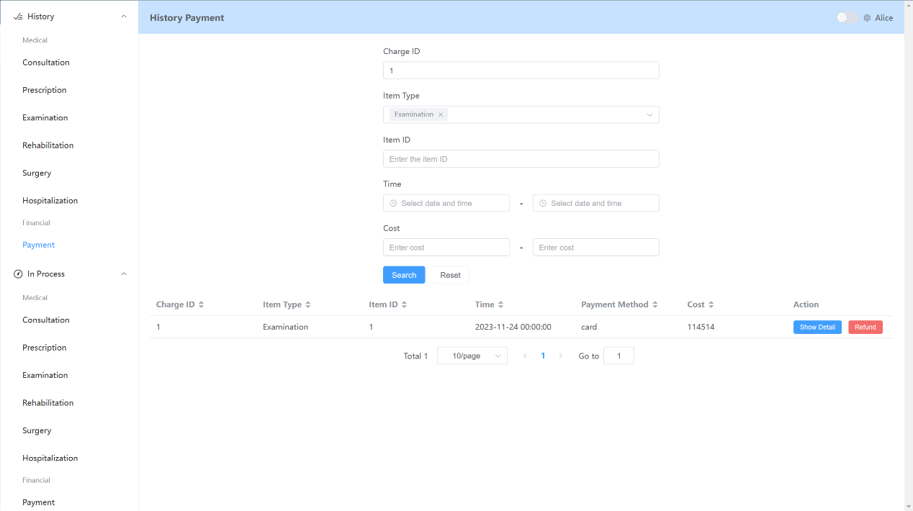

For the "In process" section highlighted in green, you can see the same items as mentioned earlier. However, in this section, only the relevant information that is currently being processed or in progress is displayed. The remaining operations and functionalities are the same as described earlier, and there is no need to repeat them.

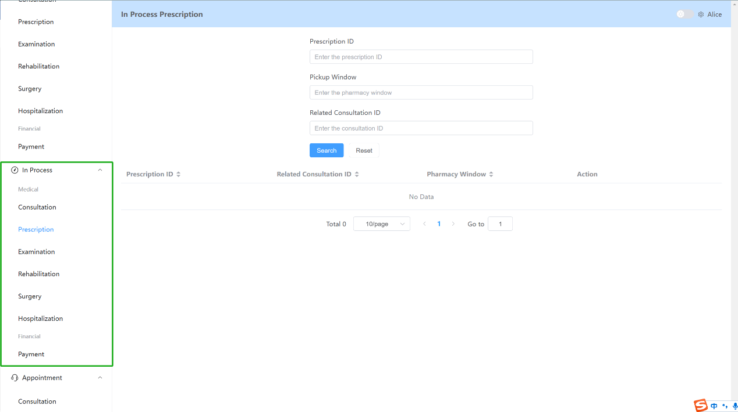

For the "Appointment" section highlighted in yellow, you can search for doctors who have available time slots for appointment scheduling. As shown in the image, you can see the doctor's department, name, position, available appointment times, and appointment fees, among other details.

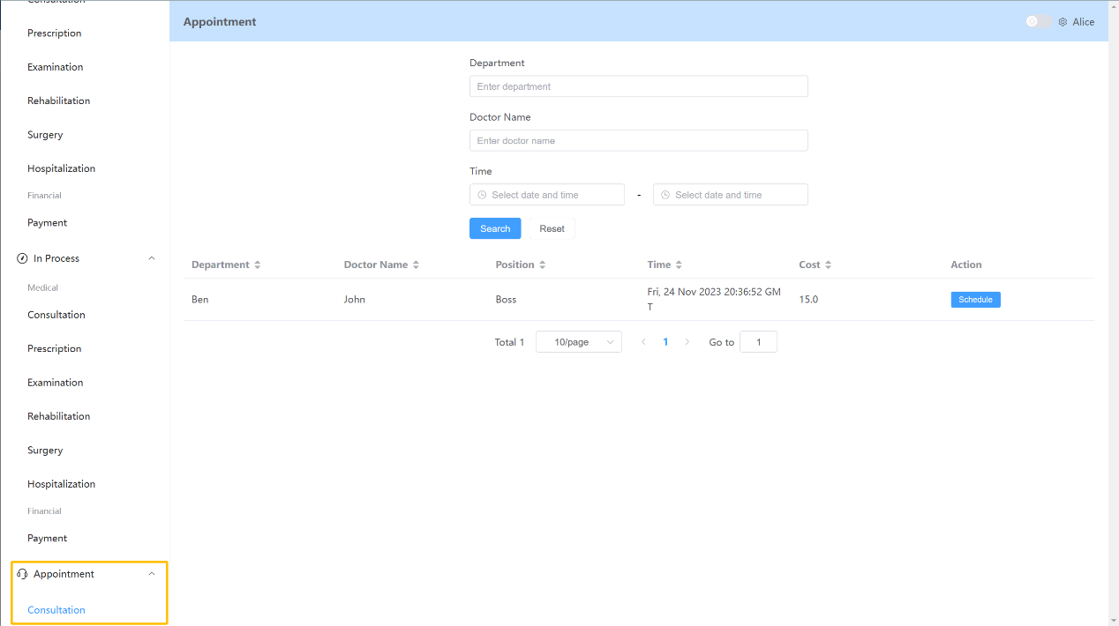

You can click the blue "Schedule" button to make an appointment with the specified doctor. After clicking the button, a confirmation prompt will appear. Click "Confirm" to finalize the appointment.

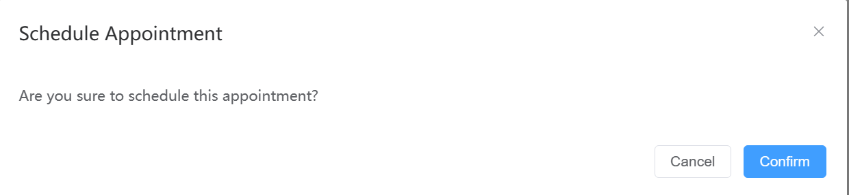

### Doctor's Perspective

The personal information and operations for doctors are similar to those of patients. Here, the focus will be on introducing the main functional operations in the doctor's interface.

#### Record Interface

As highlighted in the red box, the Record section includes the Consultation, Prescription, Examination, Rehabilitation, Surgery, and Hospitalization interfaces. These interfaces are primarily used by doctors to handle relevant operations that have not yet been recorded.

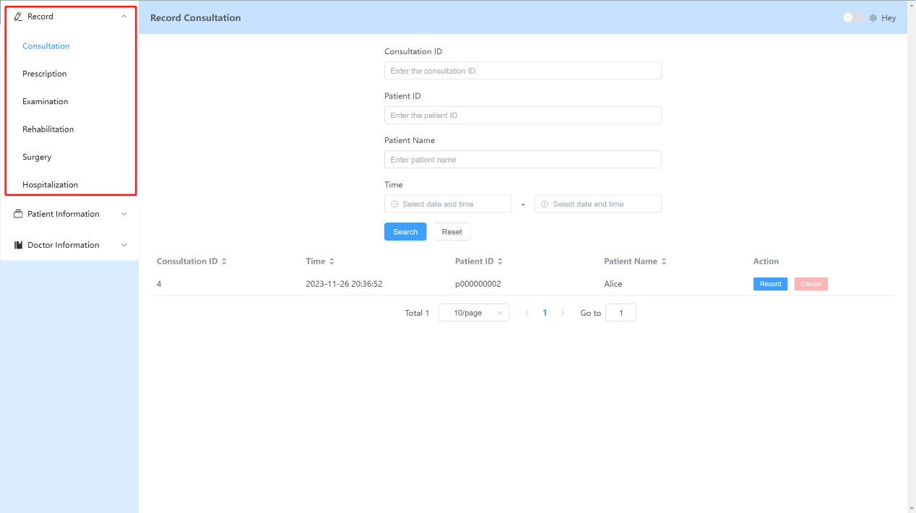

1. **Consultation**

The Consultation interface is used by doctors to record relevant information about patients. Doctors can use filters to select the specific Consultation they need to record. By clicking the "Record" button on the search results, doctors can begin recording the relevant information about the patient.

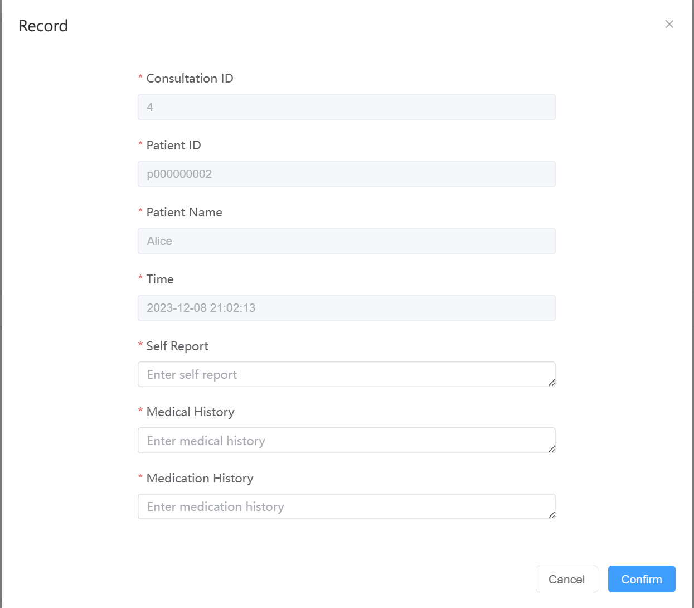

Doctors can fill in the relevant information about the patient and perform various operations such as prescribing medication, ordering examinations, recommending rehabilitation, scheduling surgeries, or arranging hospitalization.

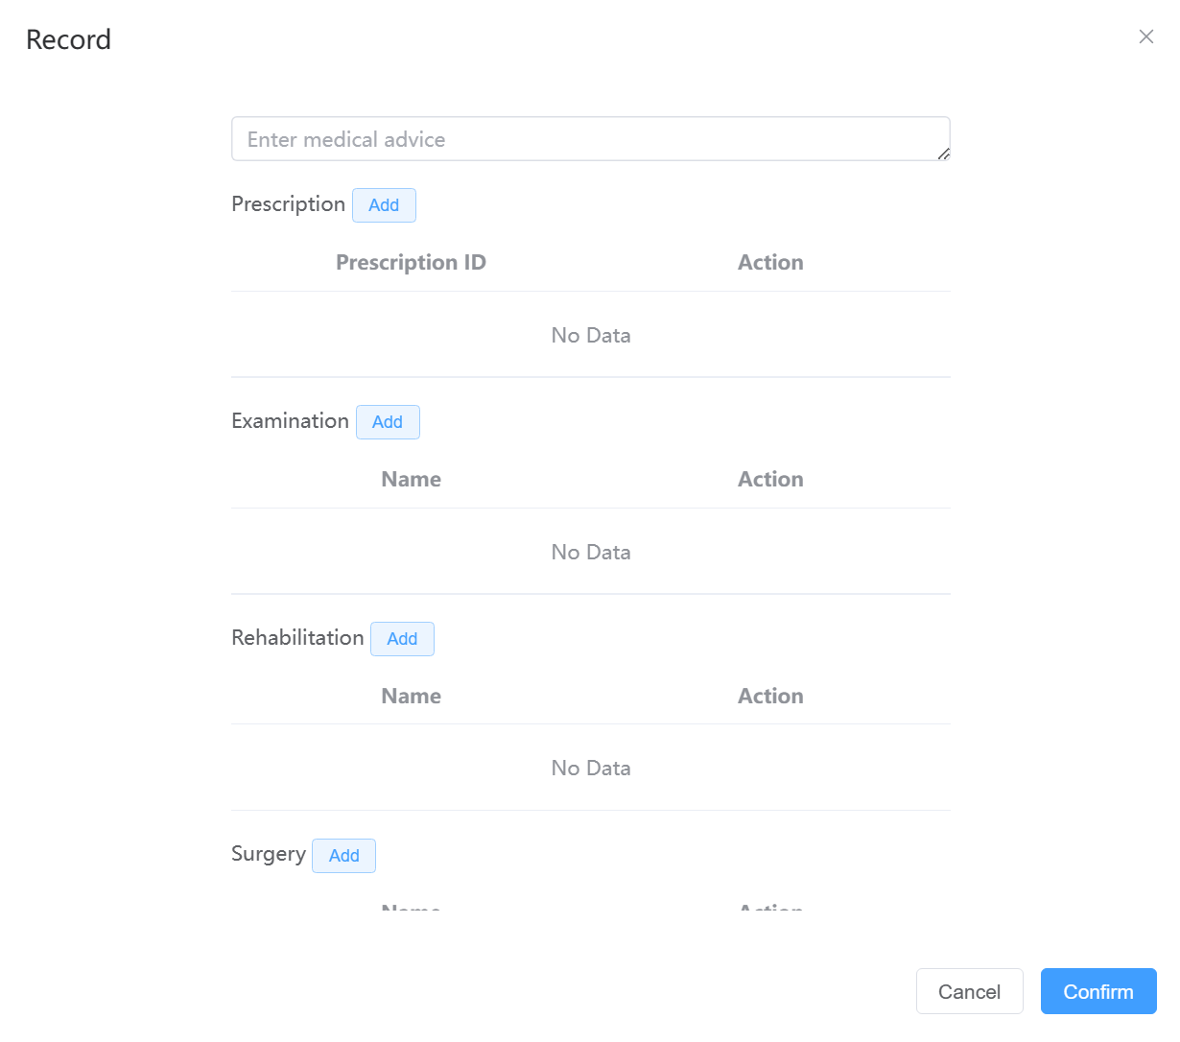

Taking Examination as an example, when you click the blue "Add" button, you will enter the patient's Examination record interface. You can follow the system's prompts to fill in the information such as the examination name, examination date, and examination time. Once you have completed the filling, click the "Confirm" button to confirm the successfully entered information. The filling process for other items follows a similar guide as Examination, so it will not be repeated here.

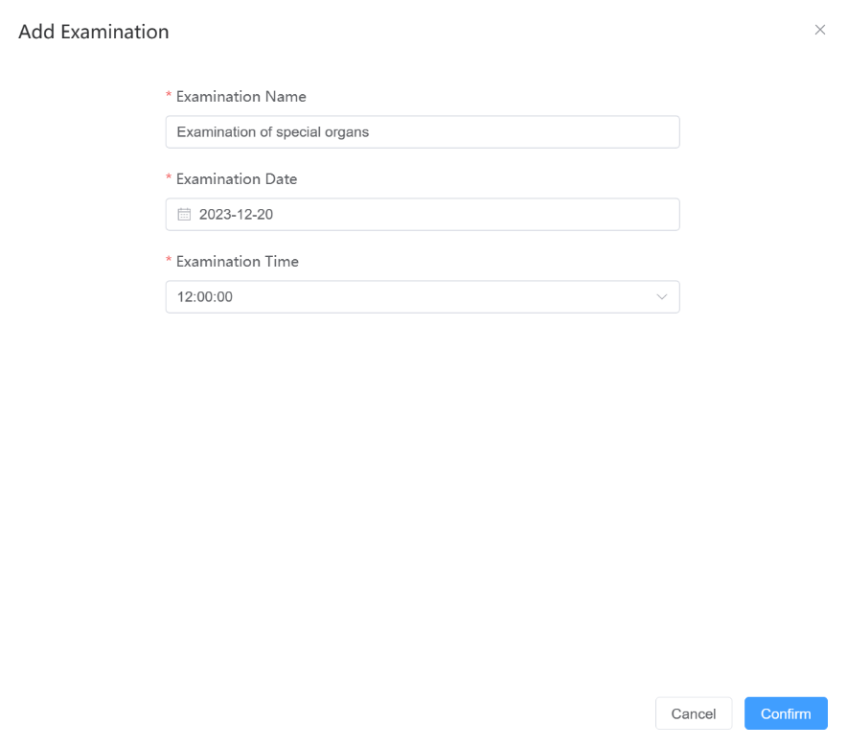

Please note that after completing all the entries, it is important to click the "Confirm" button to confirm all the operations. Otherwise, the system will not record your actions.

1. **Prescription**

The Prescription interface is used by doctors to confirm the prescription operations. It also supports filtering based on conditions. By clicking the blue "Record" button, you can confirm the prescription information for the patient. You need to review all the medications listed in the prescription. By clicking the "Check" button, you can confirm the specified medication. Once you have confirmed all the medications without any errors, click "Confirm" to confirm the prescription information.

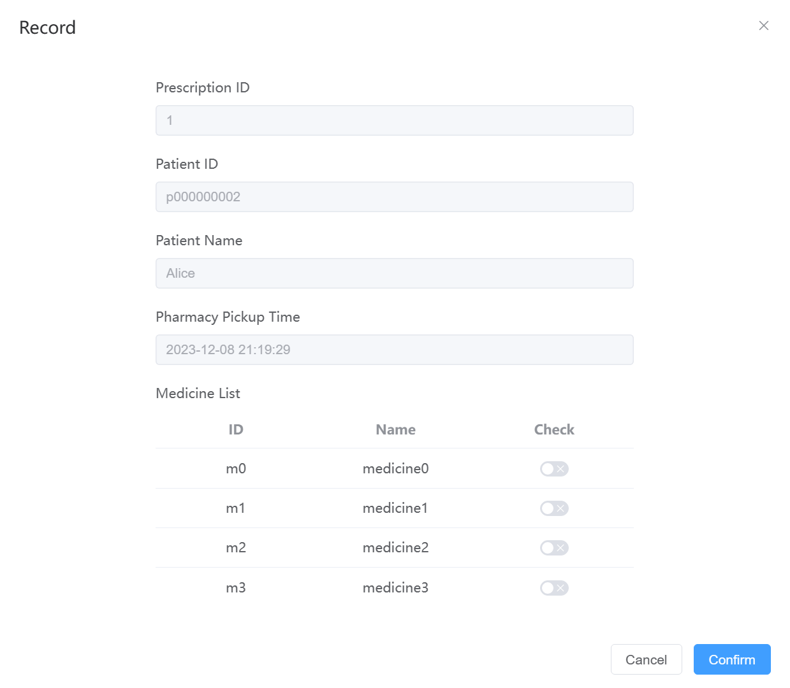

1. **Examination**

The Examination interface is used by doctors to confirm the examination orders. It supports filtering based on conditions. By clicking the blue "Conduct" button, you can view the relevant information. Clicking the "Confirm" button will confirm the patient's examination procedure.

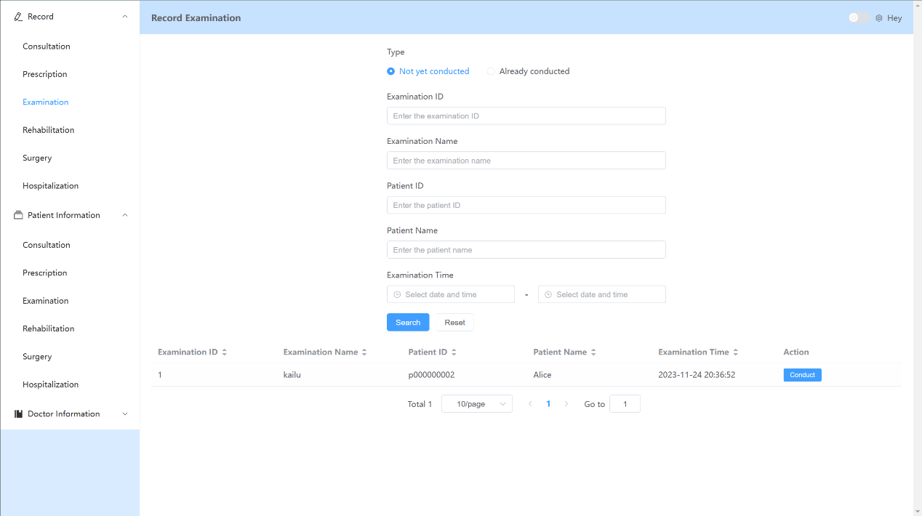

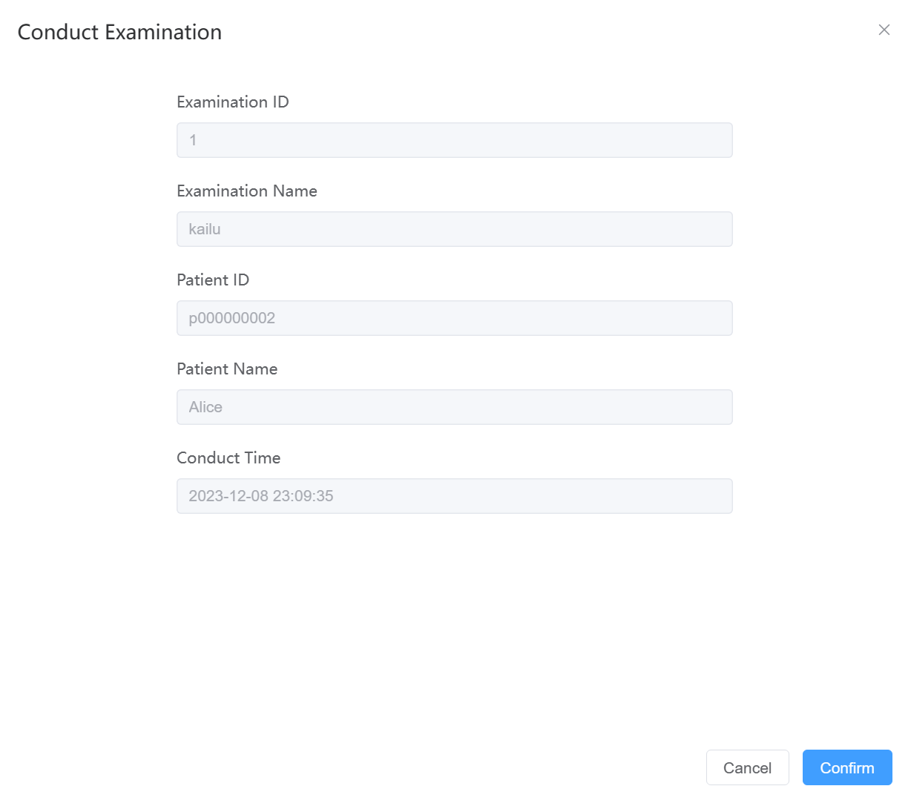

1. **Rehabilitation, Surgery, Hospitalization**

These three types of pages are similar to the interfaces described earlier, so We won't repeat them here.

#### Patient Information Interface

As highlighted in the red box, the Patient Information section includes the Consultation, Prescription, Examination, Rehabilitation, Surgery, and Hospitalization interfaces. The main functionalities and usage of these interfaces are similar to the ones described in the Record section. In these interfaces, doctors can view all the relevant patient information and also have the ability to cancel events that have not yet occurred.

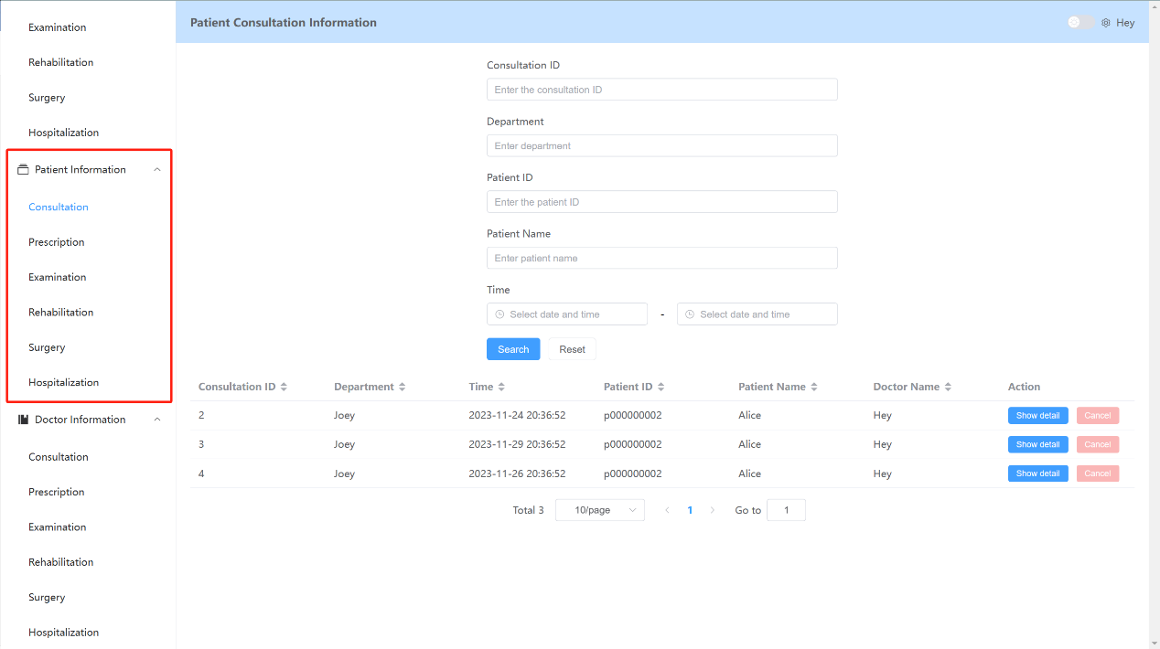

#### Doctor Information Interface

As highlighted in the red box, the Doctor Information section also includes the same interfaces as mentioned above. These interfaces are primarily used to display all the relevant medical records of the doctors' subordinates. The remaining main functionalities and usage are similar to what was described earlier.

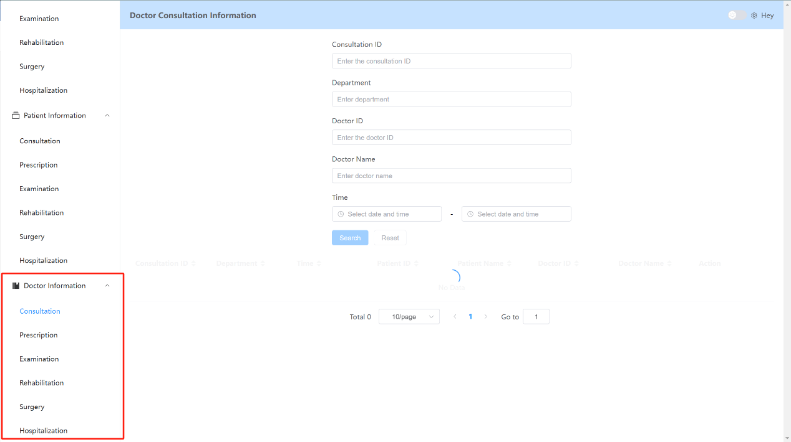

### Nurse Interface

From the perspective of each nurse, they will be assigned to specific rooms. The system will render the nurse interface display logic based on the different room assignments. Below, I will provide a detailed description of the interface functionalities for different rooms.

#### Hospitalization Room

For nurses assigned to the inpatient ward, they can see the options highlighted in the red box in the image below.

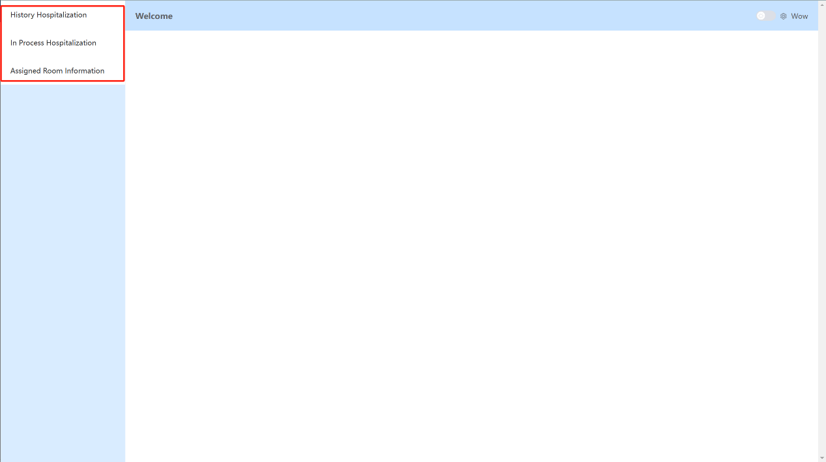

In the History Hospitalization interface, you can use filters to search for information related to yourself or your subordinates.

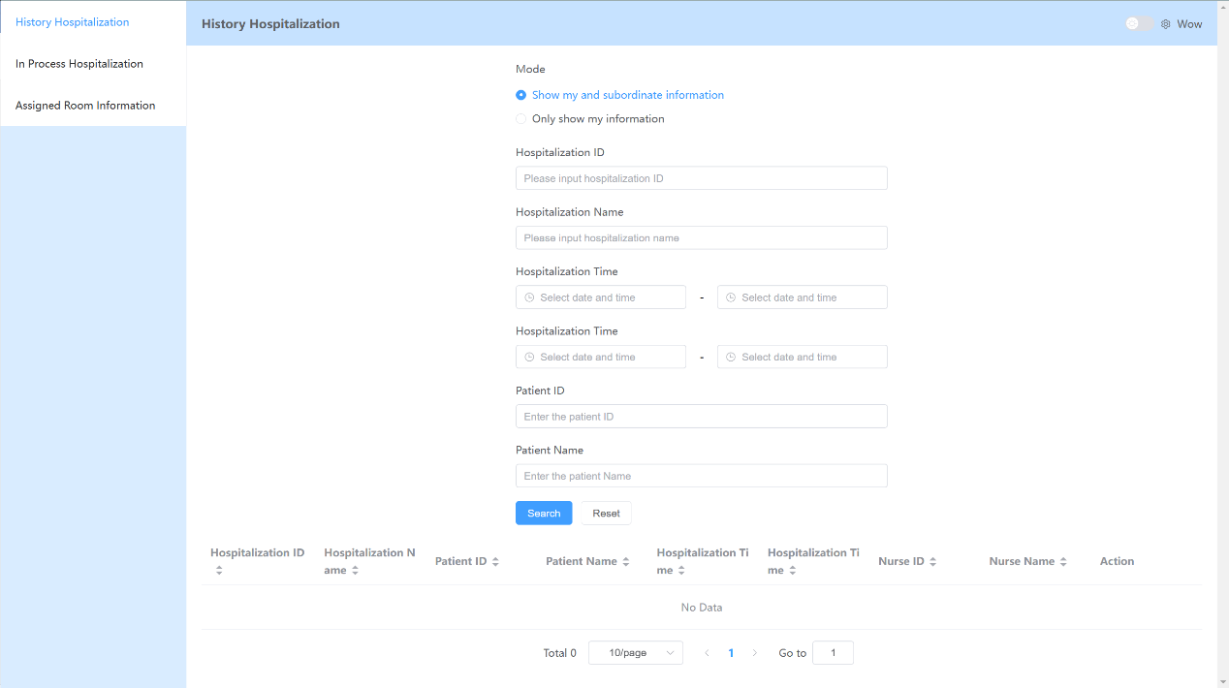

For the In Process Hospitalization interface, its functionality is similar to what was mentioned earlier, but it will only display ongoing hospitalization information.

In the Assigned interface, you can view the specific information about the rooms assigned to you. As shown in the image, you can see the room ID, room type, number of beds in the room, and other relevant information.

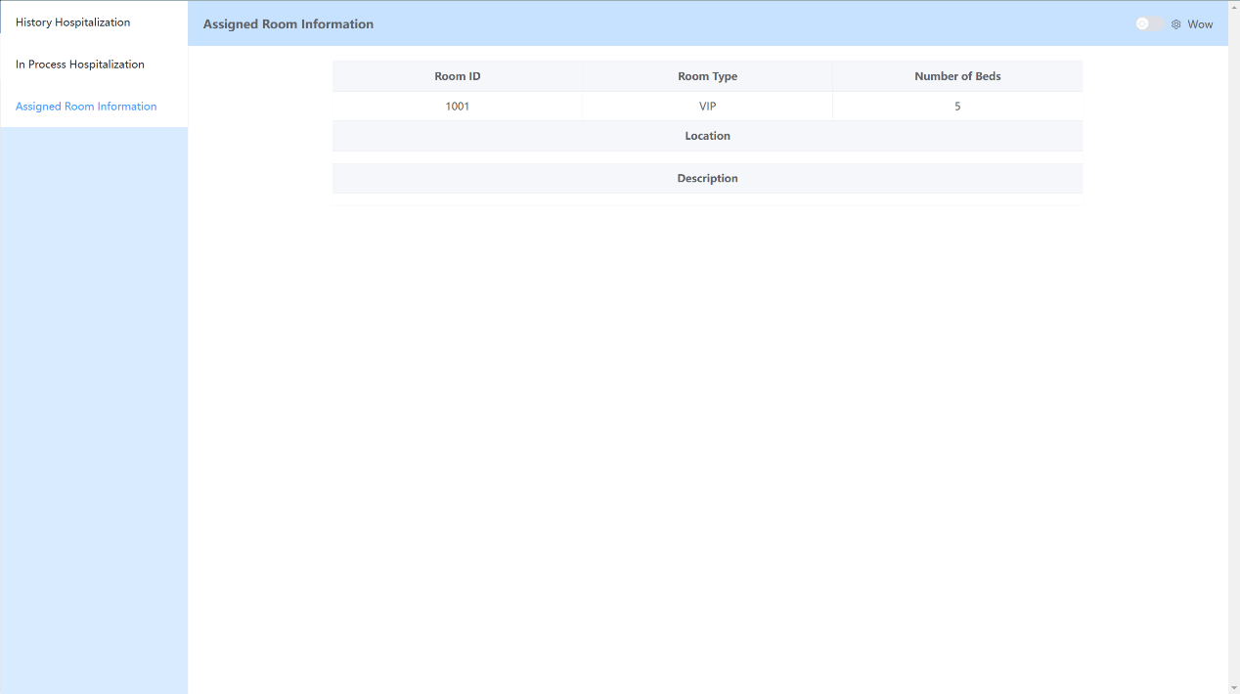

#### Examination Room

For nurses assigned to the Examination room, they can see a similar interface logic as mentioned earlier. You can view the relevant information about past surgeries, ongoing surgeries, and also the current room information.

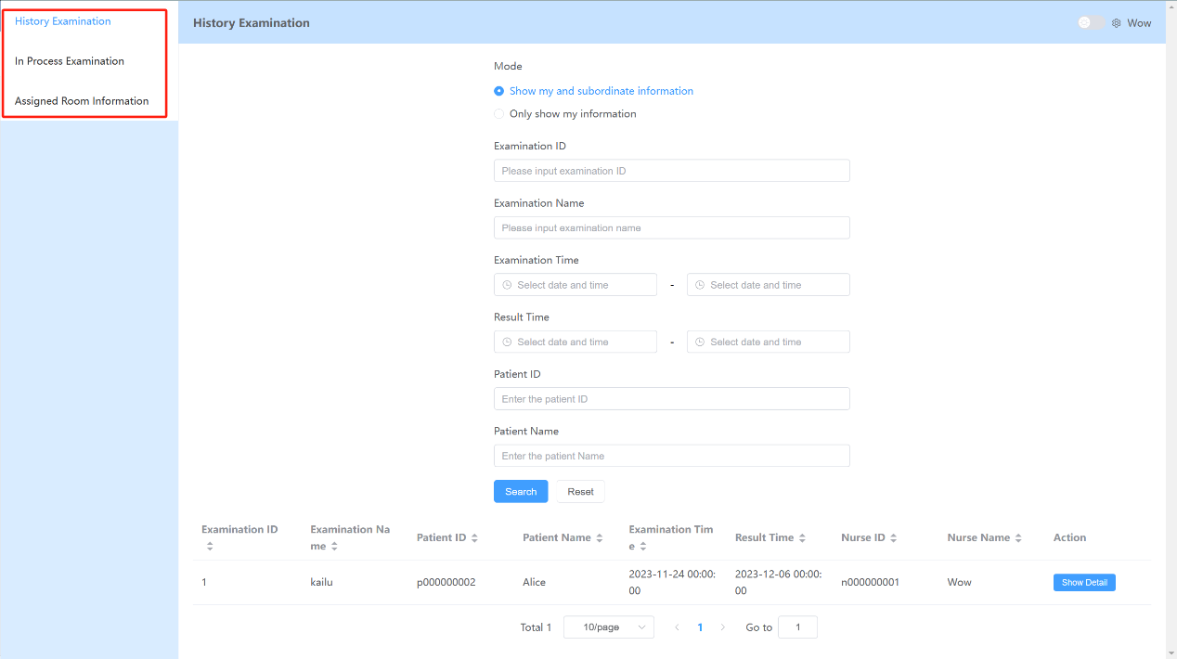

#### Rehabilitation, surgery Room

The functionalities of these two types of rooms are the same as the Hospitalization and Examination rooms described earlier, so We won't repeat them here.

### Helping staff perspective

From the perspective of each helping staff, they will be assigned to specific rooms. The system will render the interface display logic based on the different room assignments. Since the logic of this interface is essentially the same as the nurse interface logic, We won't repeat it here.

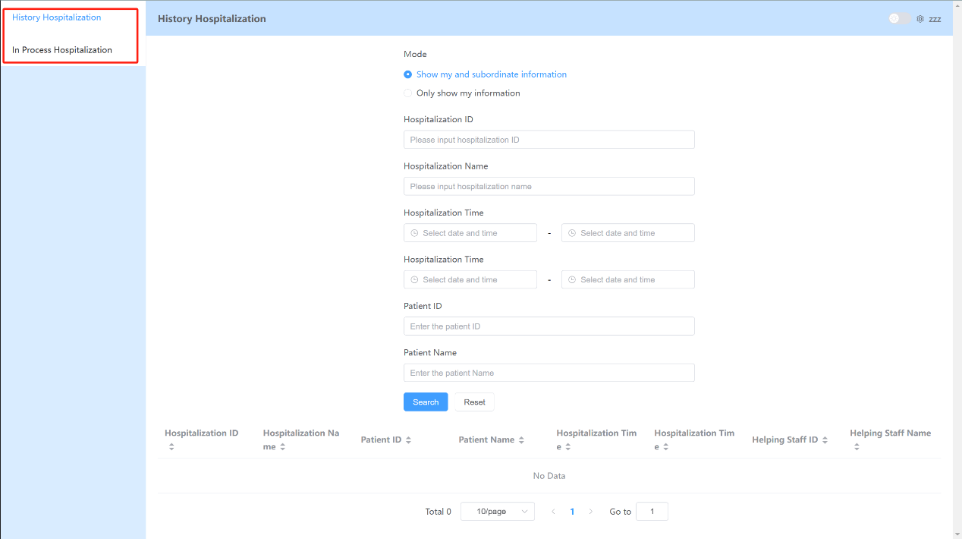

### Admin perspective

#### Adding Administrator Account

To add an administrator to the system. One should connect directly to the database and execute following SQL statement to protect the system from unauthorized persons.

INSERT INTO user(user_id, password, role, valid, register_time) VALUES user_id, sha256-hashed-password, ‘admin’, 1, CURRENT_TIME();

As a hospital administrator, you have the ability to manage users, rooms, medications, and other aspects of the entire system. As shown in the image below, highlighted in the red box, you can see a series of operations that you have permission to perform.

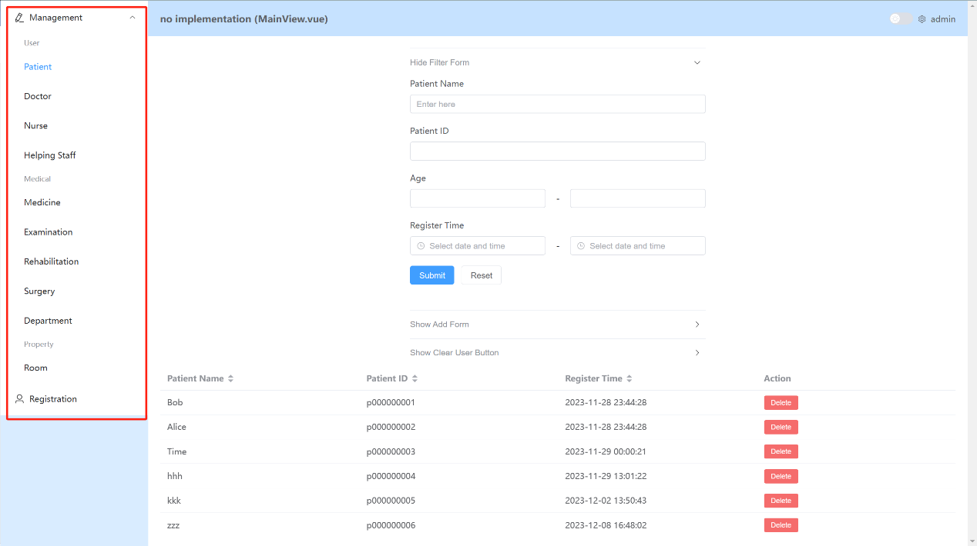

#### Managing Patients

In the Patient section, you can manage the patient information in the system. You can use filters to select the appropriate information based on conditions, and you can delete information by clicking the red "Delete" button on the far right of each entry.

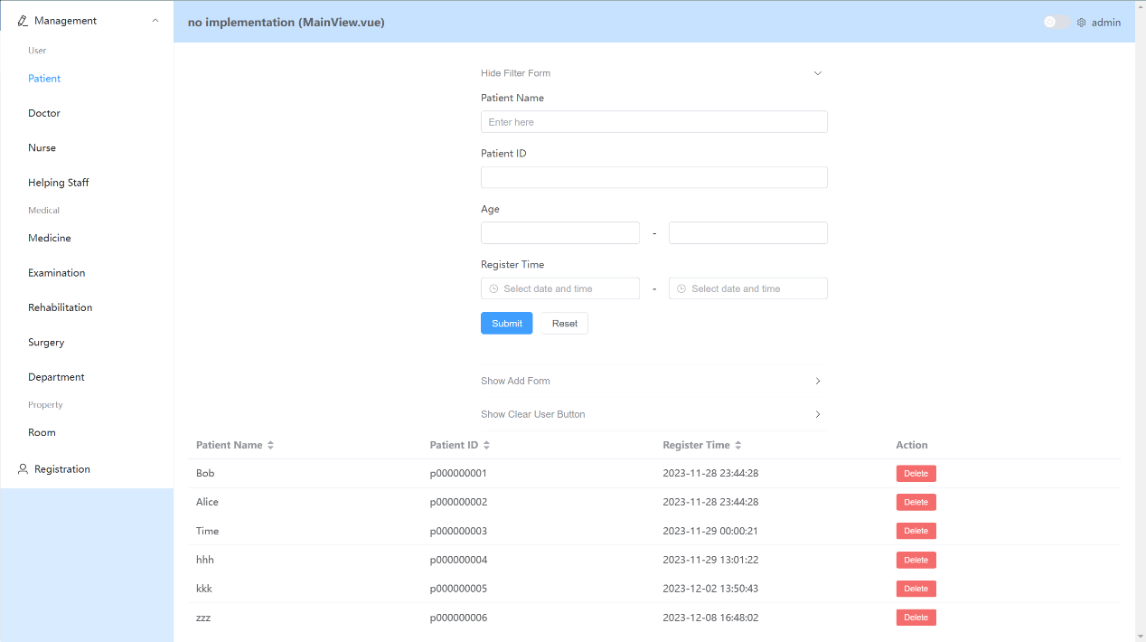

Administrators can also firmly clear all deleted user by clicking “Clear User” button. **This results in clearing all data related to a deleted user from the database!** Be careful to use this function.

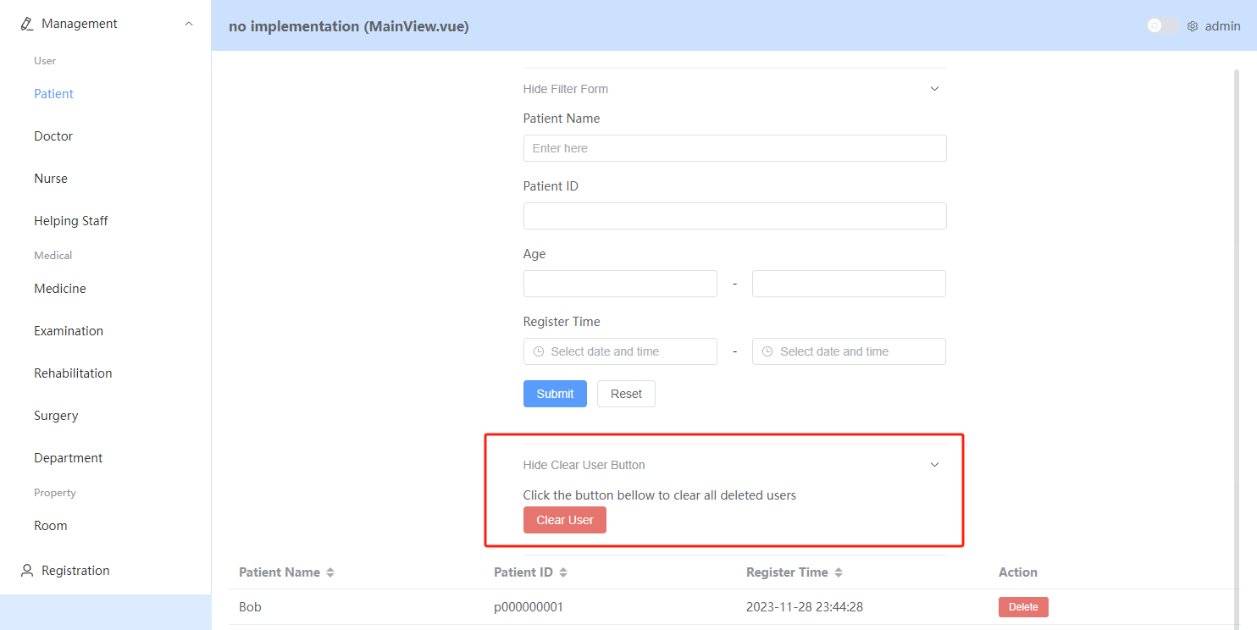

#### Managing Doctors, Nurses, and Helping Staff

The functionalities and usage logic of these interfaces are the same as mentioned earlier, so We won't repeat them here.

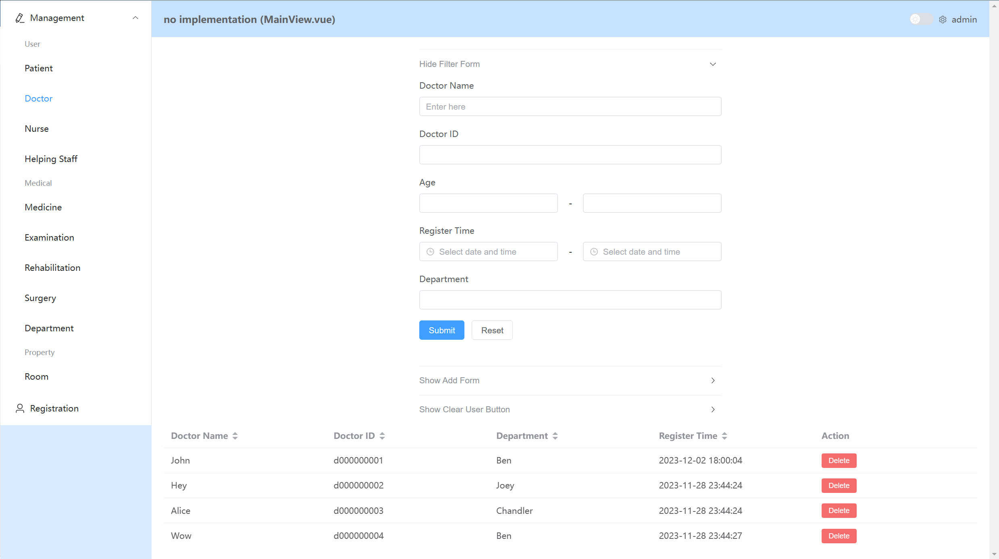

#### Managing Medications

You can manage the medications in the system under the "Medicine" section. The page supports filtering based on conditions, and it displays the names, medication IDs, manufacturers, and prices of medications that meet the criteria. You can delete specific medications by clicking the red "Delete" button on the far left.

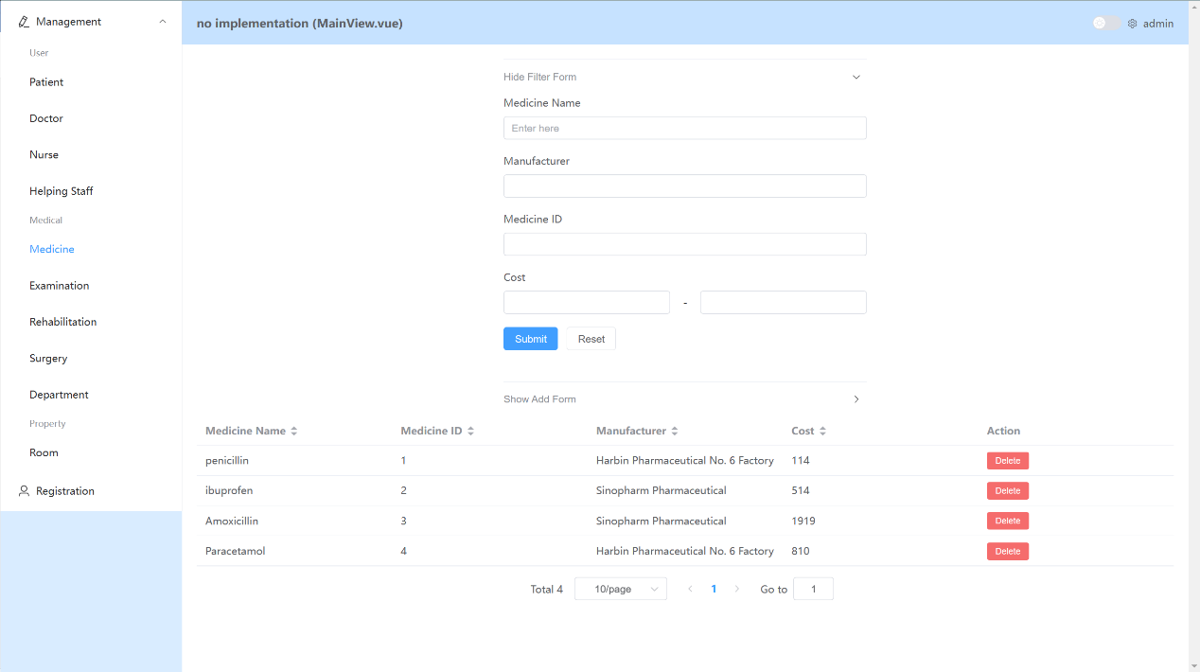

Administrators can add medicine information in add form by typing medicine name, manufacturer, cost and press Submit button.

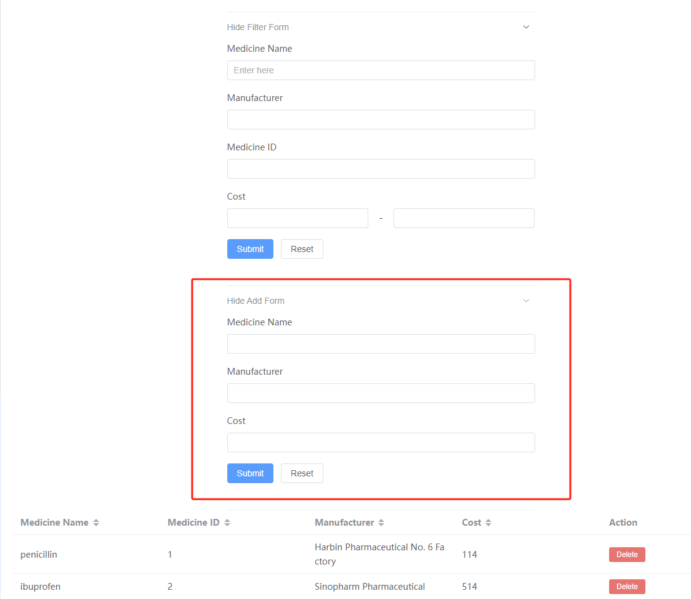

#### Managing examination, rehabilitation, surgery, department, room

The functionalities and usage logic of these interfaces are the same as mentioned above. Administrators can search for all examination, rehabilitation, surgery programs and departments, rooms in the hospital through well-designed filters. They can also add and delete any of them.

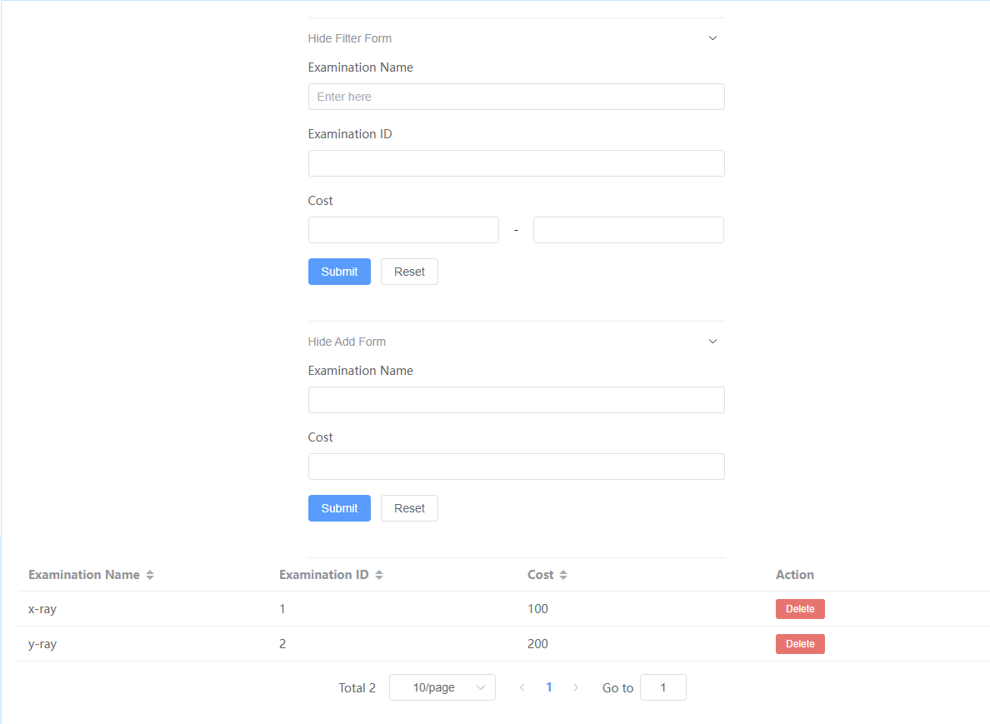

#### Managing Registration

Here, you will see the newly registered user accounts in the system. You can view their registration information and either approve or reject their registration requests. This is useful when doctors or other employees register their accounts, which are invalid initially and should wait for administrator’s approval.

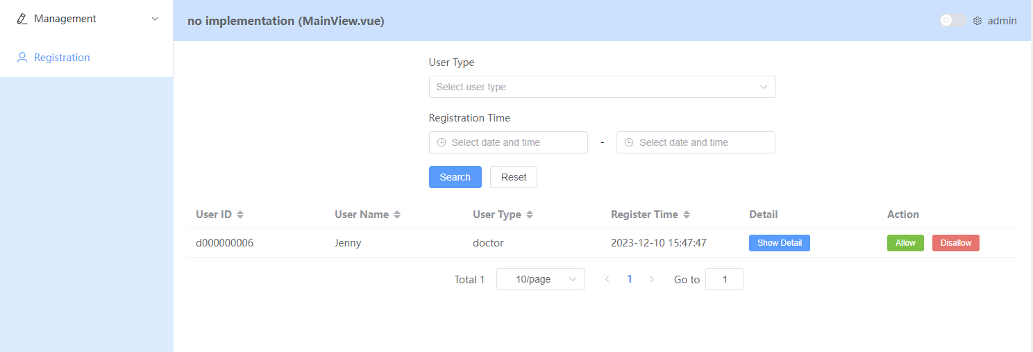

## Update and Version Control

2023.12.08 version 1.0.0 : Initial implementation of the user interface for the first version of the system.